FIELD RESAERCH PROJECT REPORT

ON

“CUSTOMER PERCEPTION TOWARDS DOMINOS”

SUBMITTED TO



“BACHELORS OF BUSINESS AND ADMINSTRATION”

SESSION 2021-2022

SUBMITTED BY: SUBMITTED TO:

MAHAK CHAWLA MR. RASHID MALIK

STUDENT OF BCOM. (H)(G.A.) CIMA Asst.PROFESOR – DEPT OF MANAGEMENT

ROLLNO. 2145010012 GLA UNIVERSITY, MATHURA

**CERTIFICATE**

This is to certify that the field research project report entitled “CUSTOMER PRECEPTION TOWARDS DOMINOS (HIGHWAY PLAAZA)”, is submitted by Ms. Mahak Chawla, student of B. Com. (H)(G.A.) CIMA of “Institute of Business Management”, GLA University, Mathura, under my supervision for the Session 2021-22.

Place: Mathura

Date: ……………………

(………..…………)

Name & Signature Supervisor

**TABLE OF CONTENTS**

**CHAPTER CONTENTS PAGE NO.**

Chapter 1 About the Company 01 – 05 Chapter 2 Introduction to the Topic, Importance & Objectives 06 – 10 Chapter 3 Research Methodology 11 - 14 Chapter 4 Data Analysis & Interpretations 15 - 18 Chapter 5 Findings, Conclusions, Recommendations & Suggestions 19 - 23

Bibliography Appendix

[Questionnaire] [Geotagged Photograph of the Student at the place of Research]

**DECLARATION**

I Mahak Chawla, student of B. Com. (H)(G.A.)CIMA Session 2021-22, Batch 2021-24 hereby declare that my work entitled “CUSTOMER PERCEPTION TOWARDS DOMINOS(HIGHWAY PLAAZA)”, is the outcome of genuine efforts done by me under the able guidance of Mr./Dr. RASHID MALIK and being submitted to “Institute of Business Management”, GLA University, Mathura as Field research project report for the session 2021-22 .

Place: Mathura

Date: …………………………

Name: Mahak Chawla

Course:Bcom(h)(G.A)CIMA

University roll no:

2145010012

**CHAPTER: 1**

**COMPANY PROFILE**

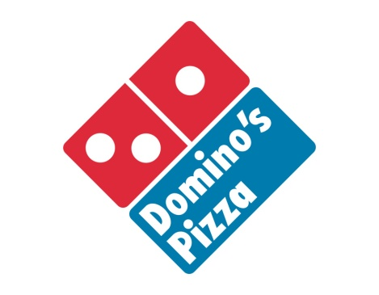

**Founded:** Ypsilanti, Michigan, U.S.

(1960)

**Headquarters:** Ann Arbor, Michigan, U.S.

Tom Monaghan, Founder

David Brandon, Chairman &

**Key people:** CEO

J. Patrick Doyle, President

(US)

**Industry:**  Restaurants

Products Pizza · sandwiches · pasta ·

Chicken wings · desserts

**Revenue:**  ▲ $1.462 billion USD

(2007)

**Employees:**  145,000

**Website:**  www.dominos.com

**Company Overview**

DMP is a quick- service pizza franchise with more than 750 stores across Australia, New Zealand, France, Belgium and the Netherlands. DMP holds the exclusive master franchise rights for the Domino's brand in these countries and also in Monaco. The Domino's brand is owned by Domino's Pizza Inc, a listed US company. DMP is the largest quick-service pizza franchise in Australia by network stores and sales and the largest franchisee for the Domino's Pizza brand in the world outside of the US and in India also.

**HISTORY**

Domino's Pizza began with one store in Ypsilanti, Michigan on December 9, 1960. Its owner, Thomas S. Monaghan, was a 23 –year –old with his brother James, he bought an existing pizza store called Dominick's Pizza. His Partnership with his brother was dissolved in 1961, By1965, Monaghan own Three stores and officially changed the company name to Domino's Pizza. Inc. A pioneer and innovator in the pizza delivery industry, Monaghan Continuously looked for better and faster ways to handle the rush. He developed a fast pizza -making method and an efficient order taking system. From the moment the phone rang to the time the pizza was delivered to the customer's door, "Never get behind" was the operating motto. He continued to emphasis the Domino's system of simplicity and speed. Monaghan also implemented the "Manager of the Year" award, a national honor presented to the company's best store crew chief they had the opportunity to advance through the ranks to become a store manager or even a franchisee.

In 1983 the company celebrated the opening of its first international store in Winnipeg, Canada. Domino's Pizza International, which Monaghan called the company's “hope for the future”. By 1989 Domino's had opened its 5000th store. By 1992 the international division had opened its 500th store outside the United States. The domestic market continued to grow with the introduction of innovative variations to the original pizza recipe as well as creative up-sell items. So he sold Domino's Pizza to Bain Capital, an organization with a proven track record of identifying companies with significant growth potential and steering them to achieve that potential.

**CHAPTER : 2**

**1. INTRODUCTION**

This research is based on customer’s perception on domino’s pizza and to test the quality of service. The fast food industry of India is experiencing phenomenal growth and is one of the fastest growing sectors in the country , Further, on the back of changing and busy lifestyle, fast emerging middle class population and the industry will continue to grow at a pace in coming years. In the developed countries and continues to expand there and in many other industrial countries in the coming years. But some of the most rapid growth is occurring in the developing world; where fast food industries are changing the way people eat. People buy fast food because it is cheap, easy to prepare, and heavily promoted and it becomes most favorite to youths. This research aims at providing information about fast food industry, its trend, reason for its emergence and several other factors that are responsible for its growth. This report provides extensive research and rational analysis on the Indian fast food industry and about the changing trends in market. The research study looks into the market condition and future forecasts, and outlines of current trends and analyses. This research has been made to help clients in analyzing the opportunities, challenges and drivers vital to the growth of fast food industry in India and basically in durg bhilai region. For the purpose of this research Fast Food Industry includes fast food restaurants, teahouses, coffee shops and juice bars in India. The 6000 corer fast food retail industry is mainly dominated by the multinational players and the key players which are active in the research of the food retailing include:

**••Dominos**

Domino's vision is focused on “Exceptional people on a mission to be the best pizza delivery company in the world!” Domino's is committed to bringing fun and excitement to the lives of our customers by delivering delicious pizzas to their doorstep in 30 minutes or less, and all its strategies are aimed at fulfilling this commitment towards its large and ever -growing customers .

Domino's constantly strives to develop products that suit the tastes of its customers, thereby bringing out the Wow effect (the feel good factor). Domino's believes strongly in the strategy of 'Think local and act regional'. Thus, time and again Domino's has been innovating toppings suitable to the taste buds of the local people and the Indian market has very well accepted these.

**OBJECTIVE**

1 To know the consumer’s satisfaction level towards domino’s pizza.

2 To know the difficulties face by domino’s pizza customers.

3 To get overall idea of the recent development in pizza industry.

**CHAPTER:3**

**RESEARCH METHODOLOGY**

**RESEARCH DESIGN**

I preferred 50 respondents as sample size in Bhilai.

Descriptive research was adopted.

**RESEARCH METHODS**

I will prefer interview and filling of questionnaire to ensure and encourage frank responses to the questions. While framing a questionnaire I will try to list a series of questions, which can provide me the needed information. For study purpose I also keep in mind the respondents understanding capacity, ability to recall the information and his experience limits. I will not include those questions, which can have misconceptions and promote non-co-operation.

**SOURCE OF DATA**

Source of data is classified in to two categories:

1. Primary data

2. Secondary data

**PRIMARY DATA**

Primary data do not exist in records and publication. The researcher has to gather primary data a fresh for the specific study under taken by him. Market researchers are interested in primary data about demographic/ socio economic characteristics, attitude / opinions / interests, motivation and behavior. Three basic means of primary data:

1. Observation

2. Survey

3. Experiment

**SECONDARY DATA**

The data referred to those, which gathered for some other purpose and are already available in the firm initial records and commercial, trade or government publications are secondary data. Sources of secondary data:

1. Published of secondary data.

2. Government publication.

3. Specialized libraries

4. General library research sources

**Sample Size:**

I used 50 respondents for my research report.

**➢ METHOD OF DATA COLLECTION:**

For getting the results of my research I used method which is questionnaire method that is under primary data.

A **questionnaire** (also known as *self-administered survey*) is a type of statistical survey handed out in paper form usually to a specific demographic to gather information in order to provide better service or goods. The questionnaire was invented by Sir Francis Galton.

• Questionnaires have advantages over some other types of surveys in that they are cheap, do not require as much effort from the questioner as verbal or telephone surveys, and often have standardized answers that make it simple to compile data. However, such standardized answers may frustrate users. Questionnaires are also sharply limited by the fact that respondents must be able to read the questions and respond to them. Thus, for some

• Demographic groups conducting a survey by questionnaire may not be practical.

• A questionnaire consists of many types of questions, like direct question, indirect question, open-ended question (free answer question), and close ended question. In this report open and close-ended questions are used. The method was discussed questioning. Each person was asked a set of question in given order and answer is limited to a list of alternative. The studies are descriptive in nature. It is connected to study the present state of affair as it exists. The open study tries to explore the system at present and report on it.

**Why questionnaire methods has been adopted**

1. It is versatile

2. Ideas related to the problem and its solution can be find by asking the people involved in various industries.

3. Knowledge, opinions, and intention of people involved can be easily founded.

4. It is usually faster and cheaper than other methods.

It involves control over the data gathering activities as compare to other method

**HYPOTHESIS TESTING**

Hypothesis testing is the often used strategy for deciding whether a sample data offer such support for a hypothesis that generalization can be made. Hypothesis testing enables us to make probability statements about population parameter(s). The hypothesis may not be proved absolutely, but in practice it is accepted if it has withstood a critical testing.

**Test adopted: t – test**

**TEST APPLIED: t - TEST**

t – test is based on the normal probability distribution and is used for judging the significance of several statically measures, particularly the mean. The relevant test statistic, t, is worked out and compared with its probable value at a specified level of significance when the sample size is less than 30 and it is used for judging the significance of the measure concerned. This is most frequently used test in research studies.

**TESTING FOR EXECUTIVES DATA:**

Formula of “t” test

t = xഥିμ

σ⁄√n

X=mean

μ = mean population

S.D. = standard deviation

n = sample size

|  |  |  |  |
| --- | --- | --- | --- |
| **S.NO** | **Xi** | **Xi-x** | **(xi-x)2** |
| 1 | 15 | -1 | 1 |
| 2 | 12 | -4 | 16 |
| 3 | 15 | -1 | 1 |
| 4 | 17 | 1 | 1 |
| 5 | 18 | 2 | 4 |
| 6 | 15 | -1 | 1 |
| 7 | 15 | -1 | 1 |
| 8 | 19 | 3 | 9 |
| 9 | 15 | -1 | 1 |
| **total** | 141 |  | 35 |

n= 30

xതതത ത = 141/9

= 15. 66 OR 16

μ **= 18 (Assumed mean)**

**S.D**.=√ (xi − x)2 n⁄ − 1

= ඥ35 9⁄ − 1

=ඥ35/8

=√4. 375

**=2.09**

**Z=** xഥ ିμ

σ⁄√n = 16ି18

2.09/√9

= 2.09/3

= I- 2.87I

= 2.87

5% level of significance

Critical value – 1.860

The null hypothesis is that consumers are satisfied with Domino’s and alternative is that consumers are not satisfied with Domino’s. So we can calculate the value of t-test and in the critical value is less than the calculated value (critical value 1.860 and calculated value is 2.87) so the null hypothesis is rejected and alternative hypothesis is accepted. That means consumers are not satisfied with domino’s pizza

CHAPTER:4

DATA AND INTERPRETATION

1.How many times you had visited domino’s ?

|  |  |  |
| --- | --- | --- |
| Response | No of response | No of response in % |
| One time | 10 | 33 |
| Two time | 15 | 50 |
| Three time | 3 | 10 |
| Four time | 2 | 7 |

1. one time b) two time c) three times d) more than three times

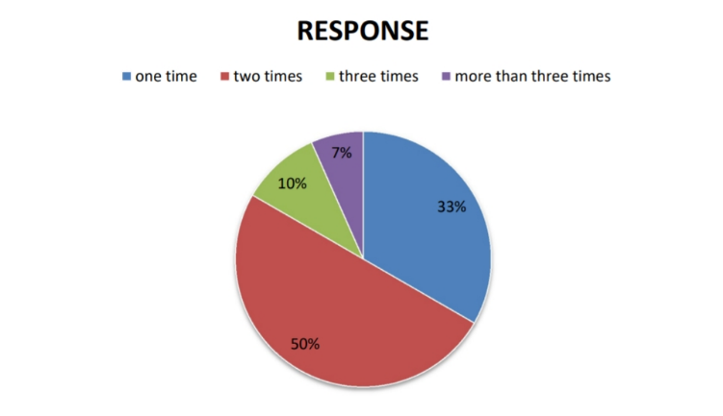

INTERPRETATION : 33 %respondents visited one time ,50 %

respondent visited two times ,10% respondent visited three times ,7 %

visited more than three times in domino’s.

2.Which item do you likes most in domino’s ?

a) pizza b) pasta c) chicken wings d) garlic breadsticks

e) choco lava cake

|  |  |  |
| --- | --- | --- |
| response | No.of response | No of in % |
| Pizza | 12 | 40 |
| Pasta | 5 | 17 |
| Chicken wings | 7 | 23 |
| Garlic sticks | 2 | 7 |
| Choco lava cake | 4 | 13 |

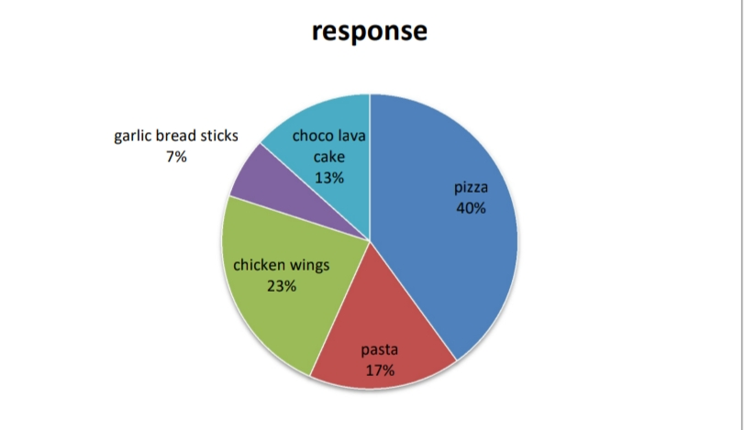

INTERPRETATIION : 40% respondent likes pizza, 17% respondent likesbn pasta ,23% respondent likes chicken wings ,7% respondent likes garlic breadsticks,13 % respondent likes chocolava cake.

3.If pizza then :

a) Veg pizza b) non veg pizza c) feast pizza

|  |  |  |
| --- | --- | --- |
| Response | No. of response | No. of in % |
| Veg pizza | 10 | 33 |
| Non veg pizza | 15 | 50 |
| Feast pizza | 5 | 17 |

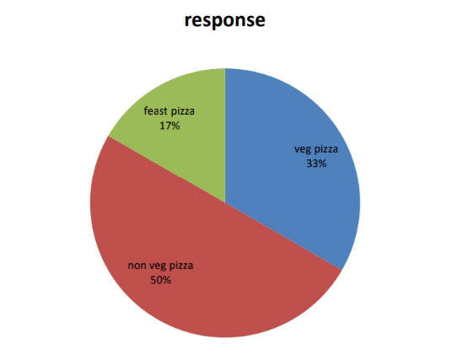

INTERPRETATION : 33% respondent like veg pizza, 50% respondent like nonveg pizza, 17% respondent like feast pizza.

4. In your opinion the speediness of the service of domino’s is?

a) good b) better c) best d) worst

|  |  |  |
| --- | --- | --- |
| response | No of response | In % |
| Good | 17 | 57 |
| Better | 5 | 16 |
| Best6 | 3 | 10 |
| worst | 5 | 17 |

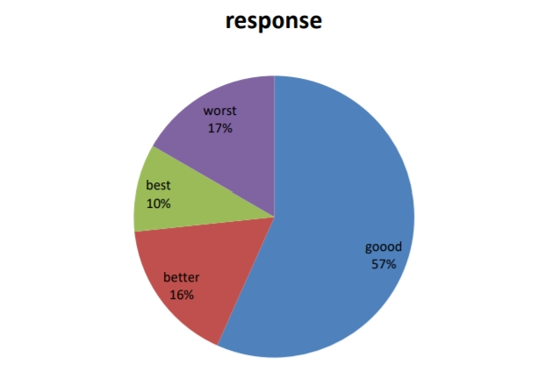

INTERPRETATION :57 % respondent says good ,16% respondent says better,10% respondent says best,17% respondent says worst.

5 . Do advertisements of domino’s influence you ?

a)YES b) NO

|  |  |  |
| --- | --- | --- |
| response | No of response | In % |
| Yes | 18 | 60 |
| no | 12 | 40 |

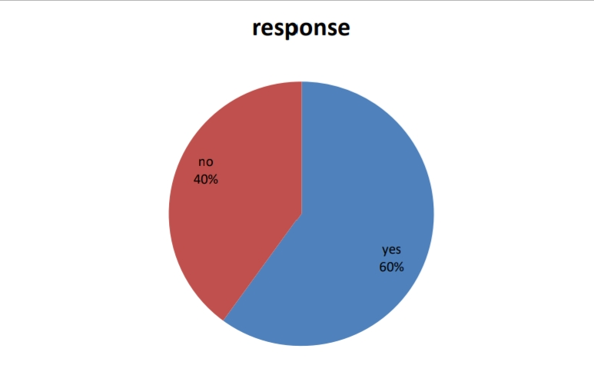

INTERPRETARION : 60% respondent says yes , 40% respondent

says no .

6.About the home delivery service of domino’s

|  |  |  |
| --- | --- | --- |
| Response | No of response | In% |
| Good | 15 | 50 |
| Better | 10 | 33 |
| best | 5 | 17 |

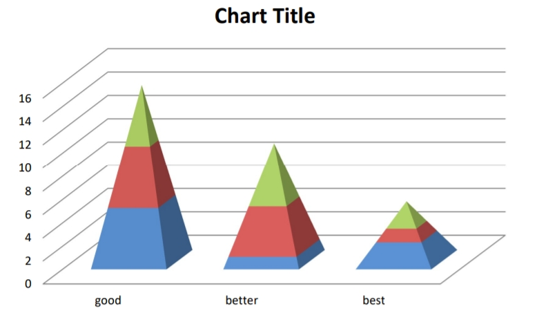

INTERPRITATION: 50% respondent says good, 33% respondent says

better,17% respondent says best.

7. The discount coupons provided by domino’s is useful or not ?

|  |  |  |
| --- | --- | --- |
| Response | No of response | In% |
| Useful | 12 | 40 |
| Non useful | 15 | 50 |
| Can’t say | 3 | 10 |

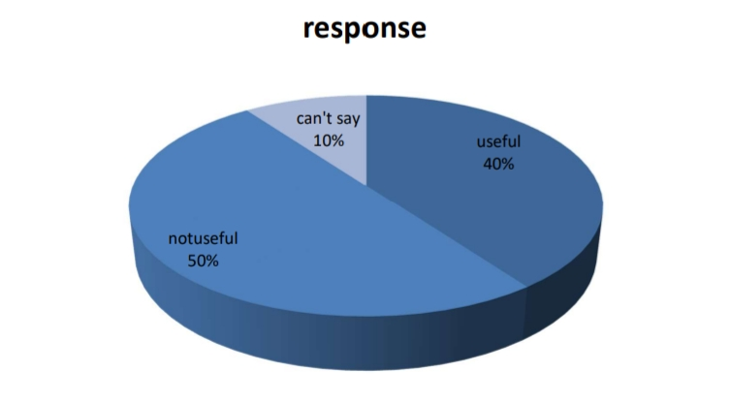

INTERPRITATION : 40% respondent says that useful,50% respondent

says that not useful,10% respondent says that can’t say.

8.What do you like to say about the price of domino’s items

|  |  |  |
| --- | --- | --- |
| Response | No of | In% |
| Low | 3 | 10 |
| Medium | 8 | 27 |
| High | 19 | 63 |

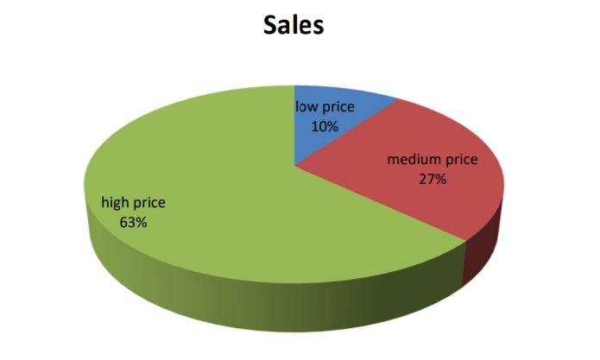

INTERPRETATION : 63% respondent says high price,27% respondent

says medium price,10% respondent saysthe price is low

9.Are you satisfied with domino’s ?

a)YES b) NO c) can’t say

|  |  |  |
| --- | --- | --- |
| Response | No of | In% |
| Yes | 15 | 15 |
| No | 10 | 33 |
| Cant’ say | 5 | 17 |
|  |  |  |

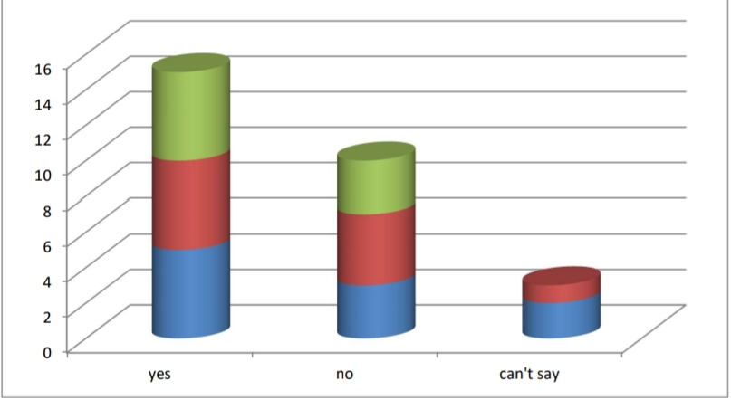

**CHAPTER- 5**

**CONCLUSION**

From the study of this survey we find that:

• The Domino’s pizza is having good concept in present market and new product in Chhattisgarh region.

• The preferences of the people for Pizza are only for outing and just for fun .

• Males are more attracted towards Domino’s pizza due to good ambiances and freshness’ rather than women’s.

• The female respondents are more attracted towards pizza and males are not responding like as female

• The quality of Domino’s Pizza is not very good .

• The study also shows that the durg –bhilai customers are not price sensitive when they get good product, quality and services. Mostly people are attracted towards new products in market

**SUGGESTION AND RECOMMENDATION**

➢ As the world is survival of the fittest, so the Domino’s have to be competitive in market for their own establishment.

➢ The Domino’s should increase its quality.

➢ The Domino’s should provide good customer services and facility.

➢ The Domino’s should reduce its charges.

➢ The Domino’s should give more discount coupons.

➢ The Domino’s having to expand its delivery area.

➢ Domino’s should improve the quality of the Pizza’s and increase the visibility in the market, & Should try to regain the trust of the Customer regarding its Door steps services.

**LIMITATION**

1. **Sample Size** Due to vast area the consumers sample size is restricted.

2**. Limitation of response** the response given to the researchers were not always Accurate since preference is qualitative indicator the Respondents regarding their understanding of Preference.

3. **Limitation of bias** generally respondents are based to the question raised, Thus the result of research will have error and the very Purpose of marketing research is lost. Therefore took Almost care while dealing with respondent.

4. **Limitation of human behavior** Researches studies the behavior that is rational. Very Often, they do not express their feeling correctly what They think. In such cases their habitual, practice Preferences cannot be assessed correctly.

5**. Limitation of time** the given time is not sufficient for this

**CHAPTER - 6**

**BIBLIOGRAPHY**

**1.C . R . KOTHARI**

**2. www.google.com**

**3.www. Dominos.com.**

**4.www.emeraldinsight.com.**

**ANNEXURE**

**QUESTIONNARIE:**

**1 . Tick the appropriate answer :**

**• Gender**

**a) Male b) female**

**• Age group**

**a) 10 – 20 b) 20 -30 c) 30 – 40 d) 40 - 50**

**• From which area do you belong (please fill in space)**

**--------------------------------------------------------**

**• How many times you had visited domino’s ?**

**b) one time b) two time c) three times d) more than three times**

**• Which item do you likes most in domino’s ?**

**b) pizza b) pasta c) chicken wings d) garlic breadsticks**

**e) choco lava cake**

**• If pizza then :**

**b) Veg pizza b) non veg pizza c) feast pizza**

**• If veg pizza then among these you like most :**

**o Margherita pizza**

**o Cheese and tomato pizza**

**o Double chesse margherita pizza**

**o Fresh veggie pizza**

**o Country special pizza**

**o Farm house pizza**

**o Peppy paneer pizza**

**o Mexican green wave pizza**

**o Deulex veggie pizza**

**o Gourmet pizza**

**• If non veg pizza then among these you like most :**

**o Cheese and barbeque chicken pizza**

**o Onion and barbeque chicken pizza**

**o Chicken Mexican red wave pizza**

**o Keema do pyaaza pizza**

**o Chicken golden delight pizza**

**• If feast pizza then among these you like most :**

**o Veg extravaganza pizza**

**o Meatzaa pizza**

**o Non veg extravaganza**

**o Cheese & pepperoni pizza**

**• In your opinion the speediness of the service of domino’s is?**

**b) good b) better c) best d) worst**

**• Do advertisements of domino’s influence you ?**

**a)YES b) NO**

**1 . Please give your opinion :**

**• About the home delivery of domino’s ?**

**-------------------------------------------------------------------------------------**

**-------------------------------------------------------------------------------------**

**------------------------------------------------------------------------------------**

**• The discount coupons provided by domino’s is useful or not ?**

**---------------------------------------------------------------------------------------**

**---------------------------------------------------------------------------------------**

**---------------------------------------------------------------------------------------**

**---------------------------------------------------------------------------------------**

**• What do you like to say about the price of domino’s items ?**

**---------------------------------------------------------------------------------------**

**---------------------------------------------------------------------------------------**

**---------------------------------------------------------------------------------------**

**• Any new type of topping do you want to suggest to domino’s ?**

**--------------------------------------------------------------------------------------**

**----------------------------------------------------------------------------------------**

**• Any type of modification do you like to suggest to domino’s ?**

**--------------------------------------------------------------------------------------**

**---------------------------------------------------------------------------------------**

**-----------------------------------------------------------------------------------------**

**-----------------------------------------------------------------------------------------**

**• Any type of difficulties face by you in domino’s ?**

**------------------------------------------------------------------------------------**

**------------------------------------------------------------------------------------**

**• Are you satisfied with domino’s :(tick the option below)**

**a)YES b) NO c) can’t say**

**5.www.pristinecareers.com .**